EMERGING METHODS

FOR EARLY DETECTION

OF FOREST FIRE

Table of Contents

1. Introduction 3

1.1 Purpose of Document 3

1.2 Project Summary 3

1.3 Background .................................................................................................................................... 2

1.4 Project Scope ................................................................................................................................. 4

1.5 System Purpose ............................................................................................................................. 5

1.5.1 Users ....................................................................................................................................... 5

1.5.2 Location .................................................................................................................................. 4

1.5.3 Responsibilities ....................................................................................................................... 4

1.5.4 Need ....................................................................................................................................... 4

1.6 Overview of Document .................................................................................................................. 4

1. Functional Objectives .......................................................................................................................... 5
   1. High Priority ................................................................................................................................... 5
   2. Medium Priority ............................................................................................................................. 5
   3. Low Priority.................................................................................................................................... 6
2. Non-Functional Objectives ................................................................................................................... 6
   1. Reliability ....................................................................................................................................... 6
   2. Usability ......................................................................................................................................... 6
   3. Performance .................................................................................................................................. 6
   4. Security.......................................................................................................................................... 6
   5. Supportability ................................................................................................................................ 6
   6. Interfaces ....................................................................................................................................... 6
3. The Context Model .............................................................................................................................. 7
   1. Goal Statement .............................................................................................................................. 7
   2. Context Diagram ............................................................................................................................ 7
   3. System Externals ............................................................................................................................ 7

Customer ......................................................................................................................................... 7

Monitoring ...................................................................................................................................... 7

Detecting ......................................................................................................................................... 7

Storing ............................................................................................................................................. 8

1. The Use Case Model ............................................................................................................................ 8
   1. System Use Case Diagram .............................................................................................................. 8
   2. Use Case Descriptions (for selected cases)...................................................................................... 8

Login................................................................................................................................................ 8

Sign Up ............................................................................................................................................ 9

Provide video feed ......................................................................................................................... 10

Select video feed............................................................................................................................ 11

Logout ........................................................................................................................................... 11

1. Appendix ........................................................................................................................................... 12

Glossary............................................................................................................................................. 12

# Introduction

## Purpose of Document

This is a Requirements Specification document for Emerging methods for early detection of forest fire. This project is used to detect forest fire early so that it could reduce vulnerability of upcoming disaster. This document describes the scope, objectives and goal of the new system. In addition to describing non-functional requirements, this document models the functional requirements with use cases, interaction diagrams, and class models.

## Project Summary

Project Name : Emerging methods for early detection of forest fire

Project Leader : Vadlamudi. Rakesh

Project Members : Muthyala.Chandrika

Mardali.Divya

Vempuluru.Hari kiran

1.3 Background

Trees are valuable carbon repositories and play an important role for the climate. It takes decades to reforest areas ravaged by wildfires. Much of this ground lies fallow for a very long time, which takes a further toll on the climate

forest fire, uncontrolled fire occurring in vegetation more than 1.8 metres (6 feet) in height. These fires often reach the proportions of a major conflagration and are sometimes begun by combustion and heat from surface and ground fires. A big forest fire may crown—that is, spread rapidly through the topmost branches of the trees before involving undergrowth or the forest floor. As a result, violent blowups are common in forest fires, and they may assume the characteristics of a firestorm. *See* wildfire.

There are a number of detection and monitoring systems used by authorities. These include observers in the form of patrols or monitoring towers, aerial and satellite monitoring and increasingly promoted detection and monitoring systems based on optical camera sensors, and different types of detection sensors or their combination.

The following part presents a brief overview of automatic and semiautomatic detection and monitoring systems of fire protection in the world, experience with these systems in practical operation, and their evaluation in terms of efficiency, accuracy, versatility, and other key attributes.

The most frequently used fire detection and suppression techniques employed by authorities can be summarised as follows:

1. controlled burning,
2. fire weather forecasts and estimates of fuel and moisture, **(iii)** watch towers,
3. lightning detectors which detect the coordinates of the strike,
4. infrared and spotter planes
5. water tankers ,mobile/smart phone calls becoming increasingly common for detecting fires

**Problems with the current system include**

* The detection mechanism used today is like watching towers, satellite imagery, video recording over long distances, etc. However, these do not provide a solution to improve the effectiveness for the detection of forest fire
* In the case of outdoor applications, abundance of sensors is required for high accuracy of fire detection systems. Every sensor also requires large battery capacity in a large open space to keep it operate. If and only if it is close to fire, sensors detect fire, but this will damage the sensor instead

* 1. Project Scope

The scope of this project is to provide the customer an early warning system of forest fire and It delivers the alert message to customer about the fire detected using cctv or drones.

Customer login or sign up the website and connect webcam links , it gives view of webcam.

Event log details are stored in database and customer details are also stored in database.

* 1. System Purpose
     1. Users

Those who will primarily benefit from the new system and those who will be affected by the new system include

Customers:

Those who will use this system to detect forest fire.

* + 1. Location

The system will be available to any potential customer using the Internet. Customers may also use the system from any location.

* + 1. Responsibilities

The primary responsibilities of the system:

* allow customers to connect webcam through the website
* allow access to use camera
* send alert messages to customer • provide services to customer

1.5.4 Need

This system is needed in order to real-time forest fire detection and prediction approaches, with the goal of informing the local fire authorities.

1.6 Overview of Document

The rest of this document gives the detailed specifications for the new sales system. It is organized as follows:

* Section 2: Functional Objectives

Each objective gives a desired behavior for the system, a business justification, and a measure to determine if the final system has successfully met the objective. These objectives are organized by priority. In order for the new system to be considered successful, all high priority objectives must be met.

* Section 3: Non-Functional Objectives

This section is organized by category. Each objective specifies a technical requirement or constraint on the overall characteristics of the system. Each objective is measurable.

* Section 4: Context Model

This section gives a text description of the goal of the system, and a pictorial description of the scope of the system in a context diagram. Those entities outside the system that interact with the system are described.

* Section 5: Use Case Model

The specific behavioral requirements of the system are detailed in a series of use cases. Each use case accomplishes a business task and shows the interaction between the system and some outside actor. Each use case is described with both text and an interaction diagram. An interface prototype is also shown. The system use case diagram depicts the interactions between all use cases and system actors.

* Section 6: An appendix containing a glossary that defines terms specific to this project

1. Functional Objectives
   1. High Priority
      1. The system shall take training sets of fire images and recognize whether there is a fire or the beginning of a fire (smoke) or if there is no fire
      2. The system shall send a notification to the admin when it recognizes a fire in the image given
      3. The system shall take real inputs of camera images and determine whether the image contains a fire or not
      4. The system shall be able to take images with a variety of sizes and convert it to one fixed image to be used throughout the application.
      5. The system shall run as a service on either a Windows or Linux operating system.
      6. In the event that the computer on which the system is running shuts down, the system service should start automatically when the computer restarts
   2. Medium Priority

1. The system shall provide following facility that will allow web pages that the user is permitted to access. The system must support the following facility:

* + - 1. Send alert message
      2. Customer data management
  1. Low Priority
     1. The system shall allow the user's status to be stored for the next time he returns to the web site. This will save the user x minutes per visit by not having to reenter already supplied data.
     2. The system shall provide information about event log of forest.

1. Non-Functional Objectives
   1. Reliability
      * The system shall be completely operational at least x% of the time. 
      * Down time after a failure shall not exceed x hours. 
   2. Usability
      * Customer should be able to use the system in his job for x days . 
      * A user who already knows what camera he is using should be able to connect and view that page in x seconds. 
   3. Performance
      * The system should be able to support x simultaneous users. 
      * The mean time to view a web page over a 56Kbps modem connection shall not exceed x seconds.. 
   4. Security
      * The system shall provide password protected access to web pages that are to be viewed only by users. 
   5. Supportability
      * The system should be able to accommodate many camera links. 
      * The system web site shall be viewable from chrome or any browser. 

* 1. Interfaces

The system must interface with

* + - The cloudant db for customer and customer log information 
    - The acquired web site search engine 

1. The Context Model
   1. Goal Statement

The various real-time forest fire detection and prediction approaches, with the goal of informing the local fire authorities. 4.2 Context Diagram

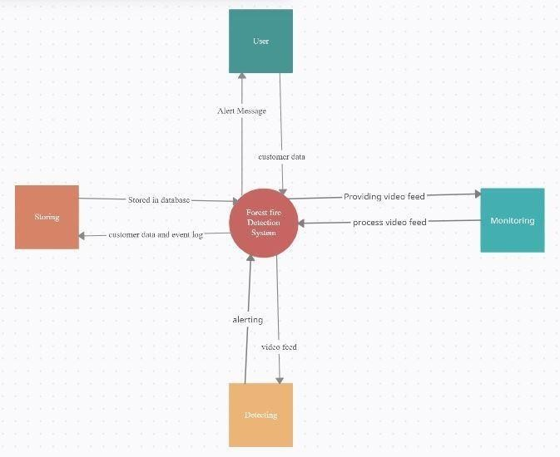

4.3 System Externals

Customer

A customer is any user of the system . A customer provide video feed and monitor the forest.

Monitoring

The system monitoring the forest by video feed and do further processing.

Detecting

The System takes video feed and process the feed. It sends alert message if fire detected.

Storing

The system stores the customer data and event log in database.

1. The Use Case Model
   1. System Use Case Diagram

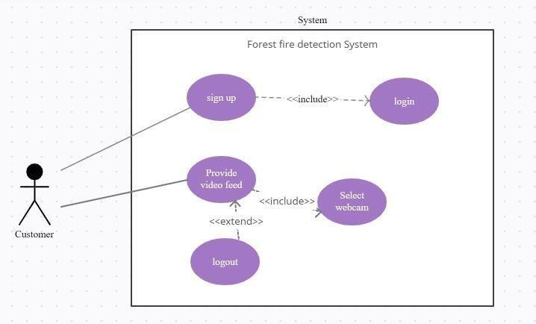

* 1. Use Case Descriptions Notes:

* + - For all use cases, the user can cancel the use case at any step that requires user input. This action ends the use case. Any data collected during that use case is lost. 
    - For all use cases that require a logged in user, the current login session is updated during the use case to reflect the navigation paths through the use case. 

Login(Sign up)

|  |  |  |
| --- | --- | --- |
| Use Case Name: | Login | |
| Summary: | In order to get personalized or restricted information, a user must login so that the | |
|  | system can determine his access level. | |
| Basic Flow: | 1. | The use case starts when a user indicates that he wants to login. |
|  | 2. | The system requests the username and password. |
|  | 3. | The user enters his username and password. |
|  | 4. | The system verifies the username and password against all registered users. |
|  | 5. | The system starts a login session and displays a welcome message based on the user's preferences. |
| Alternative Flows: | Step 4: | if username is invalid, the use case goes back to step 2. |
|  | Step 4: | if the password is invalid the system requests that the user re-enter the password. When the user enters another password the use case continueswith step 4 using the original username and new password. |
| Extension Points: | login |  |
| Preconditions: | The user is registered. | |
| Postconditions: | The user can now obtain data and perform functions according to his registered access level. | |
| Business Rules: | Some data and functions are restricted to certain types of users or users with a particular access level. | |

Sign up(Customer)

|  |  |
| --- | --- |
| Use Case Name: | Sign up |
| Summary: | In order to get personalized or restricted information, a new user must sign up a username and password. |
| Basic Flow: | 1. The use case start when a user indicates that he wants to register. 2. The system requests a username and password. 3. The user enters a username and password. 4. The system checks that the username does not duplicate any existing registered usernames. 5. The system requests a name (*), street, city, state, zipcode(*), phone and email address. Items marked by (*) are required. 6. The user enters the information. 7. The system determines the user's location and access level and stores all user information. |
|  | 8. The system starts a login session and displays a welcome message based on the user's preferences |
| Alternative Flows: | * Step 4: If the username duplicates an existing username the system displays a message and the use case goes back to step 2. * Step 5: If the user does not enter a required field, a message is displayed and the use case repeats step 4. |
| Extension Points: | *Register Preferences* |
| Preconditions: | none |
| Postconditions: | The user can now obtain data and perform functions according to his registered access level. |
| Business Rules: | . Access levels are    o 0: A user can access only data classification 0 o 1: The user can access data classification <= 1 o 2: The user can access data classification <= 2    The default access level is 0. |

Provide Video feed (Customer)

|  |  |
| --- | --- |
| Use Case Name: | Provide video feed  Scenario: Customer provide video feed |
| Summary: | This use case allows a registered customer to provide video feed. |
| Basic Flow: | 1. The use case start when a customer indicates he provides the feed . 2. The customer may add or change any webcam. 3. The system tells the customer to select the webcam. 4. The system displays camera view. |
| Alternative Flows: | Step 6:  If the selected camera could not be validated, go to step 8 to get another camera. |
| Extension | None |
| Preconditions: | The customer is logged in and has completed a selection of the camera |
| Postconditions: | The camera view is displayed. |
| Business Rules: | If a customer has selected correct camera. |

Select video feed(Provide video feed)

|  |  |
| --- | --- |
| Use Case Name: | Select video feed  Scenario: Customer Select video feed. |
| Summary: | This use case allows Customer Select video feed. |
| Basic Flow: | 1. The use case start when a customer indicates he provides the feed. 2. The customer may add or change any webcam. 3. The system tells the customer to select the webcam. 4. The system displays camera view. |
| Alternative Flows: | None. |
| Extension Points: | *None* |
| Preconditions: | The Customer provides video feed. |
| Postconditions: | The camera view is displayed. |
| Business Rules: | None |

Logout(Customer)

|  |  |
| --- | --- |
| Use Case Name: | Logout |
| Summary: | This system log out. |
| Basic Flow: | 1.The use case allows user to logout. |
| Alternative Flows: | none |
| Extension Points: | none |
| Preconditions: | The system is executing use case logout. |
| Postconditions: | None. |
| Business Rules: | None |

1. Appendix

Glossary

* + - Forest fire detection system based on wireless sensor network on IEEE paper. 
    - Forest fire detection system based on satellite images on IEEE paper. 